BSc in Software Development
Year 3

COMP07030 Software Design Project

<Data Visualization>
<G00294191>
<Sean Fitzpatrick>

Contents
Introduction 3
Architecture of the solution 3
Class diagram and Data Model 3
Technologies used 3
Problems Encountered/Solved 4
Conclusions 4
Recommendations 4

Student Number: G00294191
Student Name: Sean Fitzpatrick
Supervisor: Brian McGinley
GitHub Link: https://github.com/seanJosephFitzpatrick/dataVisualization.git

Introduction
This project is based on Data Visualization. Visually representing data using visual aids such as charts. The data will be held on a Neo4j Graph database.
The database will be hosted on a cloud computing platform called Windows Azure that allows end users to host applications on virtual machines, servers and databases. The languages used for the Data Visualization project will be HTML Hyper Text Markup Language, JavaScript and JQuery. The client side application will be rendered and loaded in the browser.

Aims
To visually represent data based on a remote server using visual aids. The data will be acquired over the network using a REST representational state transfer API application program interface.

Objectives
- To store the data on a NoSQL database call Neo4j.
- Retrieve the data using a jQuery AJAX (asynchronous JavaScript and XML) POST method.
- The POST method will send a Cypher Query for selecting data from the database.
- The selected data will be processed into bar and pie charts using D3.js (Data Driven Documentation). A JavaScript library for manipulating documents based on data.

Architecture of the solution
Windows Azure: cloud computing platform that allows you to create Virtual machine, servers and databases and run applications in the cloud.
- Gmitsoftware.cloudapp.net: virtual machine created on Windows azure for hosting the database
  - Neo4j: NoSQL graph database to hold the data
- Gmitsoftware.azurewebsites.net: web server created On windows azure to host Data Visualization project
  - Data visualization project
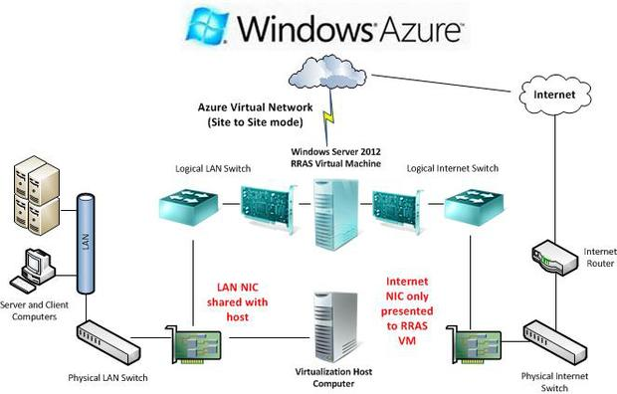
Dropbox: cloud storage service that allows users to sync file over the Internet
- Index.html: html file
- postRequest.js: javascript file
- animate.js: javascript file
- style.css: cascading style sheet

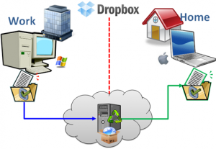

Class diagram and Data Model

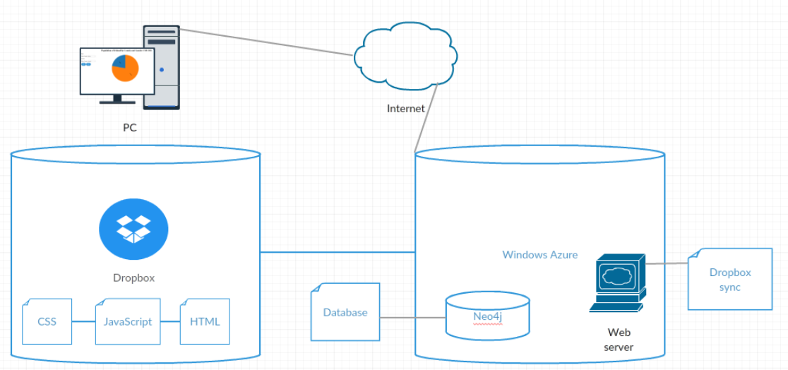

Neo4j Database Graph Model of Connacht:

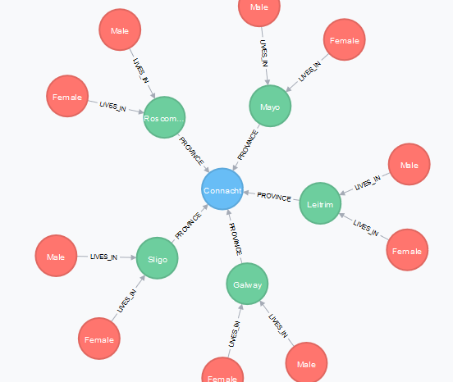

Technologies used

Neo4j is a NoSQL Graph Database. Data is represented in the database as nodes and as directed-relationships between those nodes. Nodes and relationships can hold additional information known as properties. If a node represents a person then the properties of that node might be age, sex, height, Personal Identification Number. A relationship between two person nodes might represent a paternal relationship such as brother and sister. There would be a relationship from the male node saying “Brother of” female node and a relationship from the female node saying “Sister of” male node. These relationships may also contain properties that would be specific to the relationship between the two nodes; such as a school, gym or swimming club that may have been attended by both nodes.

Neo4j is a highly scalable native graph database that leverages data relationships as first-class entities, helping enterprises build intelligent applications to meet today’s evolving data challenges.
A graph is composed of two elements: a node and a relationship.
Each node represents an entity (a person, place, thing, category or other piece of data), and each relationship represents how two nodes are associated. This general-purpose structure allows you to model all kinds of scenarios – from a system of roads, to a network of devices, to a population’s medical history or anything else defined by relationships.
A graph database is an online database management system with Create, Read, Update and Delete (CRUD) operations working on a graph data model.
Unlike other databases, relationships take first priority in graph databases. This means your application doesn’t have to infer data connections using things like foreign keys or out-of-band processing, such as MapReduce.

D3.js is a JavaScript library for manipulating documents based on data. D3 helps you bring data to life using HTML, SVG, and CSS. D3’s emphasis on web standards gives you the full capabilities of modern browsers without tying yourself to a proprietary framework, combining powerful visualization components and a data-driven approach to DOM manipulation.

JavaScript is an interpreted language that has support built into all modern web browsers. Code can be written in a text editor and run directly in the browser. Some text editors like Notepad++ or Brackets have built in functions for executing the code in a browser.

Dropbox is a Web-based file hosting service operated by Dropbox, Inc. that uses cloud computing to enable users to store and share files and folders with others across the Internet using file synchronization.

Windows Azure is a cloud computing hosting site that allows you to create Virtual machine, servers and databases and run applications in the cloud. I am using this service for hosting the Neo4j database as the service is free as part of the module. Neo4j has its own web server and is configured to listen on all ports. The code is on Dropbox and is synced to a web server on Windows Azure.

HTTP Hypertext Transfer Protocol is the foundation of data communication for the world wide web. Http is a stateless protocol that does not retain session information between devices. Once the transaction ends between devices the connection ends. Http is a RESTful (Representational state transfer) API (Application Program Interface) that allows devices to communicate with each other over the Internet.

Problems Encountered/Solved

One problem was with the jQuery AJAX POST request. I did not fully understand the Asynchronous request and how it worked. When a request is made, the code continues to execute. When the request returns with data, its success function passes the data to the specified function, also known as a call-back function.

Once I managed to get the call back function working, I had a problem with scope. I could access all the variables if I put the code into the call back function but could not access the inner bar() or pie() functions because they were nested. If I placed the code outside of the call-back function I was able to access the bar() and pie() functions but was unable to access the returned data from the AJAX POST request.

It turned out in the end that this too was due to the Asynchronous POST request. The variables to assign the data to the charts was coming back too late. By the time the call back function had returned the rest of the code was executed and the variables for the charts were null and returning NAN.

I got around this problem by setting the Asynchronous POST request to false. It is not ideal and not recommended to do so but it get the job done. The charts do not load up on the page until the call-back returns the data.

I got the Async to work in the end. The rendering code for drawing the charts is in the callback and the pie() and bar() function are outside of the callback function and are both callable. The variables needed for both to work are set globally.

Async By default, all requests are sent asynchronously (i.e. this is set to true by default). If you need synchronous requests, set this option to false. Cross-domain requests and dataType: "jsonp" requests do not support synchronous operation. Note that synchronous requests may temporarily lock the browser, disabling any actions while the request is active.

HTTP Whenever your web browser fetches a file (a page, a picture, etc) from a web server, it does so using HTTP ("Hypertext Transfer Protocol"). HTTP is a request/response protocol, which means your computer sends a request for some file (e.g. "Get me the file 'home.html'"), and the web server sends back a response ("Here's the file", followed by the file itself).

Another problem was with setting up the database on the server. After many attempts to try and connect with the server through a RESTFUL API I could not make the connection. One of the errors received was a CORS (Cross-Origin Resource Sharing) error.

After many attempts trying to find the cause to this problem it turned out to be a miss spelling in one of the Endpoints in Windows Azure. Instead of calling the Endpoint for port 7474 (Neo4j), I had it called databases. Once this problem was corrected the connection to the database went smoothly.

Azure Endpoint settings on the AzureVM allows us to configure the incoming traffic such as remote desktop, custom http ports (Teamcity, OctpusDeploy and etc.) to the VM. It was pretty easy to find that setting on old HTML5 azure portal https://manage.windowsazure.com.
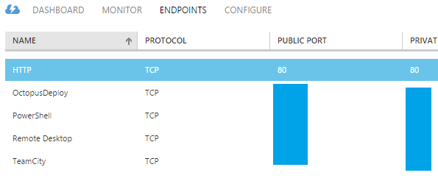

Conclusions

This is the first project that brings together a database and client side application that can communicate with each other over the network. This project allowed me to host a database, client side application and code in the cloud. The client side application is run in a web browser hosted as a website. The web server can deploy code from an external source, for this I used Dropbox. The database has its own web server and user interface. The database, client side application and the code can be accessed through a browser anywhere in the world.

Recommendations

The project could be further developed by using more advanced charts. Instead of getting the data from a static database, the data could come from a site where the data is constantly changing like a Currency Exchange site or a Stock Market site.

This technology can be used with JQuery mobile or bootstrap to develop it into a mobile application.

What would I do differently if I was to start again, I don’t know. I know it would not take as long as it did and that I would have it set up to where it is now relatively quick. So I would probably advance further on the client side with more advanced visualization charts.

[https://azure.microsoft.com/en-us/][Thursday 21 April 2016]
http://www.ucc.ie/info/net/whatis.html
https://en.wikipedia.org/wiki/JavaScript
http://api.jquery.com/jquery.ajax/
[http://webtechorigin.blogspot.ie/2013/11/windows-azure-virtual-networking-now.html][Monday 25 April 2016]
[http://www.technotricks.in/videos/dropbox-explained-in-simple-terms/][Monday 25 April 2016]
[http://seriouslymen.com/cloud-storage-compared-carbonite-vs-drive-vs-dropbox/][Monday 25 April 2016]
[http://neo4j.com/] [18/04/2016 12:16:19]
[http://neo4j.com/why-graph-databases/] [18/04/2016 12:16:19]
[https://d3js.org/] [Monday 18 April 2016]
[http://www.technotricks.in/videos/dropbox-explained-in-simple-terms/][Monday 25 April 2016]
[http://searchcloudcomputing.techtarget.com/definition/Windows-Azure] [Monday 18 April 2016]
[https://en.wikipedia.org/wiki/Hypertext_Transfer_Protocol][Sunday 24 April 2016]
[http://api.jquery.com/jquery.ajax/] [Monday 18 April 2016]
[http://rve.org.uk/dumprequest] [Monday 18 April 2016]
[http://michaelsync.net/2015/09/28/where-is-the-endpoint-setting-for-vm-in-new-azure-portal] [Monday 18 April 2016]

